Welcome!
Date
Name
Spouse
Address
City
State Zip _________
Email

Please Contact By
❑ Card  Phone  Visit

Telephone Best Time to Call
Home ______________
Work ______________

Guest: First Time Second Time
Are you a church member: yes no
Church
City, State

Circle Appropriate Age/Grade Group(s)
Preschool: Ages: B-1 2-3 4-5
Children: Grades: K 1 2 3 4 5 6
Youth: Grades: 7 8 9 10 11 12
Adults: Ages:18-29 30s 40s 50s 60s+

How did you learn about our church?
Newspaper Friend Yellow Pages Mail
Other

I am a guest of:

New in the Community? Yes No
Names & ages of children at home

Weekly Service & Activity Schedule

May 17, 2015
9:45 a.m. Sunday School
11:00 a.m. Morning Worship Service
Independence Association Music Festival – Brenham
No Evening Worship Service

Week of May 17, 2015

Wednesday 7:00 p.m. Adult Prayer & Bible Study

Upcoming Events
May
24……………………………….……………Veteran’s Service
24…………………………………………….Business Meeting
28……………………………………………..Adult Fellowship
31………………………………………….KSBC Homecoming



Join us for our Veteran’s Day Service on May 24 as we salute the men and women who have served and are currently serving in the Armed Forces.


Remember KSBC Homecoming is just around the corner. Memories, music, fellowship, and great food!!

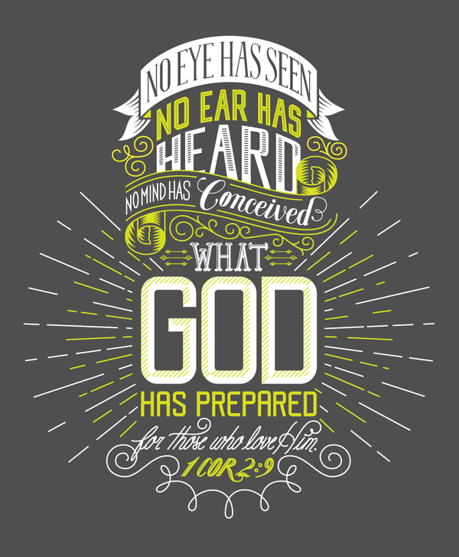

Knobbs Springs Baptist Church

May 17, 2015

Church Information:

KnobbsSpringsBC.com KnobbsSpringsBaptist@gmail.com
1662 CR 305, McDade, Texas 78650 512-273-2743
David Atwood, Pastor Cell 512-470-5098
Home 512-856-2819
Patti Radford, Office Manager Cell 512-968-7821

